|  |
| --- |
| Online marketing institute & training pvt ltd |
| O.M.i.T - Assignment |
| Social Media/SEO/SEM |
|  |
|  |
|  |

|  |
| --- |
| Submitting the assignment as given by the faculty of O.M.i.T |

**Assignment - 1 DATE:27/5/19**

**Assignment Name: Social Media/SEO/SEM**

**Faculty- NIKAHATH**

**Q1. Business analysis for orient flight aviation academy**

**A1.** ORIENT FLIGHT AVIATION ACADEMY

1. OBJECTIVE : Orient Flight Aviation Academy are providing 2 types of orientation courses they are Aviation and Civil Aviation courses
2. Aviation: Aviation is the study of aeronautics and the grandeur of academic metamorphosis

Civil Aviation:

* Cabin Crew Training
* Ground Staff Training
* Certificate Course in Dangerous Goods and Cargo
* Flight Dispatches Training Program
* RTR (Radio Telephony Restricted)
* Airline Ticketing

1. Target Audience : For Aviation: 10th/ plus two (physics ,Mathematics , English)or equivalent

Civil Aviation: plus two, graduate, 12th diploma

1. LOCATION: Aviation : Mysore & Civil Aviation : Chennai
2. Age Group : aviation: 18 years completed Civil Aviation : 18 & 26
3. Gender : male & female

KEYWORDS:

* Orientation courses in Bangalore
* Aviation course in Bangalore
* Best orientation courses in Bangalore
* Orientation courses near me
* Aviation summer courses
* How to apply aviation courses
* Best cabin crew training
* How to apply cabin crew
* Good authorized aviation training center
* Good authorized cabin crew training center

**Assignment - 2 DATE:27/5/19**

**Assignment Name: ORM**

**Faculty- Nikahath**

**Q1. Find relevant keywords for the digital marketing agency CITRIC IDM from google keyword planner**

**A1.** Keyword search is orm agency

**ORM - ONLINE REPUTATION MANAGEMENT**

* ORM COMPANY 10-100 LOW
* REPUTATION MANAGEMENT SERVICES 100-1K MEDIUM
* ONLINE MARKETING COMPANIES 1K-10K MEDIUM
* ONLINE REPUTATION MANAGEMENT SERVICES 10-1K LOW
* REPUTATION MANAGEMENT SERVICE 100-1K MEDIUM
* REPUTATION SERVICES 10-100 LOW
* ONLINE REPUTATION MANAGEMENT SERVICE FOR INDIVIDUALS 10-100 LOW
* ONLINE REPUATATION MANAGEMENT SERVICES INDIA 100-1K LOW
* BRAND REPUTATION MANAGEMENT SERVICES 10-100 MEDIUM
* ONLINE REPUTATION MANAGEMENT SERVICE PROVIDER 10-100 MEDIUM

**Assignment - 3 DATE:27/5/19**

**Assignment Name: SEO**

**Faculty- NIkahath**

**Q1. Q1. Find relevant keywords for the digital marketing agency CITRIC IDM from google keyword planner**

**A1.** Keyword search is orm agency

Keyword (by relevance)

* SEO agency
* SEO service provider agency
* SEO
* Search engine optimization service provider
* Search optimization
* SEO service provider
* SEO optimization service
* Marketing SEO service
* Website SEO service
* Search optimization company

SMM SOCIAL MEDIA MARKETING

* SOCIAL MEDIA ANALYSIS LOW 100-1K
* SOCIAL MEDIA CONSULTANT LOW 100-1K
* SOCIAL MEDIA MARKETING AGENCY LOW 100K-1M
* SOCIAL MEDIA OPTIMIZATION LOW 1K-10K
* SOCIAL MEDIA MARKETING MEDIUM 10K-100K
* SOCIAL MEDIA MARKETING WEBSITE MEDIUM 10-100
* ONLINE SOCIAL MEDIA MARKETING HIGH 10-100
* SMM LOW 1K-10K
* SOCIAL MEDIA SERVICS LOW 100-1K
* SOCIAL MEDIA MARKETING WEBSITE MEDIUM 10-100

**Assignment - 5 DATE: 28/5/19**

**Assignment Name:**

**Faculty- NIKAHATH**

**Q1.**

**A1.** Title tag for citric idm

* Digital marketing agency and services in Bangalore|citric idm
* Orm agency in bangalore|best orm services|citric idm
* social media company and best social media statergy-citric idm
* content marketing agency |services-citric idm
* Best seo company in Bangalore| seo agency-citric idm

**Assignment - 6 DATE: 29/5/19**

**Assignment Name: SEO**

**Faculty- NIKAHATH**

**Q1.**

**A1.**META DESCRIPTION FOR TITLE TAG

|  |  |
| --- | --- |
| Title Tag | Meta description |
| Digital marketing agency and services in Bangalore|citric idm | Digital marketing agency with service like SMM,SEM,SEO,CONTENT MARKETING are included in citric idm |
| Orm agency in bangalore|best orm services|citric idm | ORM agency with best ORM services in Bangalore LISTING,REVIEW  MANAGEMENT,SEARECH,REPUTATION are included in citric idm |
| social media company and best social media statergy-citric idm | Social media company and provide best social media statergy. Top SMM services are provide in citric idm |
| content marketing agency |services-citric idm | Creavtive Content marketing agency in Bangalore top content marketing services provided by citric idm |
| Best seo company in Bangalore| seo agency-citric idm | Best SEO agency in Bangalore SEO and optimization service provided by citric idm |

**Assignment – 7 DATE: 29/5/19**

**Assignment Name:**

**Faculty- NIKAHATH**

**Q1.**

**A1.**

H1- Citric IDM - Digital Marketing Agency

H2- WHO We- WORK FOR- Excited to partner with brands in their digital marketing journey

Our- Digital Marketing Services

Search Engine Optimization (SEO)- We provide complete SEO services to get your business to reach and retain a higher position and get a better ROI

Search Engine Marketing (SEM)- Citric IDM gives you SEM services involving intensive research to give you a better ROI with each click

ORM Services- We understand the importance of reputation hence we have ORM experts to enhance the ORM of your Business

Content Marketing Services- We make sure that any content we write for you will get customers to engage more with your business

Social Media Services- We look after Monitoring, Strategizing and Executing a creative and effective Social Media plan for your business

Web Development Services- We don’t only develop your website, we craft it with passion to ensure a great platform for you to interact with your customers

H3- Presenting CITRIC IDM

More than Just a Digital Marketing Company

Passion for Unlimited Creativity

Quick Links

Citric IDM - Digital Marketing Company

#4, Adithya Chambers, 1 st Main Road, 2 nd Block, 3 rd Phase, Basaveshwaranagar, Bengaluru,

H4- Ravikiran J -CEO, OMiT

M. Nirneeth Reddy CEO, Timeforpet

H5- SEO

SEM

SOCIAL MEDIA

Orm

Web development

CONTENT MARKETING

Get ready to join our community!

H6- Quick Enquiry

**Assignment – 8 DATE: 30/5/19**

**Assignment Name:**

**Faculty- NIKAHATH**

**Q1. Content creation about beauty store**

**A1.**

**HEADING - BE BEAUTY**

**TAGLINE - “BEAUTY IN YOUR HANDS”**

Every girl wish to have a good skin and a pretty appearance. Introducing be beauty to help you in selecting skincare and beauty products. Beauty is an extremely overwhelming world and there are more products available than you could ever possibly use or need in a lifetime.

Before choosing a foundations and concealers, get yourself a nice basic skincare routine because no makeup looks good on bad skin.

Some of the beauty products

1. Good vibes – shea butter deep moisturizing body lotion

Loaded with vitamins and fatty acids shea butter nourishes skin incredibly. created for all and highly recommended for dry skin

2. Innsfree - aloe revital soothing gel

A soothing multi-purpose aloe gel that clams down your skin extensively. can be used for hair care as well.

3. Laneige - lip sleeping mask

This product is meant to intensely, moisturize your lips

4, Clinique - hydrating gel

Clinique moisture surge 72-hour auto – replenishing hydrator is a refreshing gel cream that gives your skin the power to rehydrate itself.

5, Kama – Ayurveda toner

Rose water is a natural astringent .it balances and restores skin’s PH level and helps tighten pores . rose water is also a good non-alcoholic toner

6,plum- hello aloe caring day moisturizer

Purest natural ingredients . soft, glowing skin every day! plum’s 1 organic best seller . say goodbye to dryness irritation and dullness .this day cream is a light moisturizer to keep your face hydrated, nourished, and most importantly,happy!

A recent society of dermatology skincare specialists (SDSS) study shows that 88% of women don’t know the right products ‘for their skin’.itsnot surprising given the incredible amount of skincare ‘must haves’ and ‘must-do’ solutions available in the market. This blog will tell you how to care yourself…….choose right things for your skin..

**Assignment – 9 DATE: 3/6/19**

**Assignment Name:**

**Faculty- NIKAHATH**

**Q1. Content creation about beauty store**

**A1.**

**HEADING - NATURAL BEAUTY TIPS**

**TAGLINE - “BEAUTY IN NATURE”**

Now a days everyone is spending more time and cash for skin care in beauty salons. But without chemical treatment it is possible to protect the skin with natural home remedies. From home itself we can do the beauty care without side effects with the help of natural home remedy which helps to make the skin better.

Natural home remedies does not causes any side effect. It only makes skin better it is possible to do natural skin care from itself with the organic products available. In olden days girls used the natural home remedy for skin care like turmeric, sandal, etc. now a days Ayurveda skin products are more expensive and in demand than the chemical products .various skin care problems can be solved using the skin care remedy.

* NATURAL SCRUB – mix rice flour with some yogurt and apply it all over your face. Scrub it gentle. twice a week to see healthy glow
* Mix honey with some turmeric and apply it over your face for 20 mins.to remove tan from your face
* Apply chilled aloe Vera gel on your face twice everyday consistently to fade away acne marks and sun spots. Regular usage gives hydrated and plump skin.
* Dip a towel in warm water and squeeze out the excess. Wrap it around your hair for 10 min. and then follow up by applying a mask made of banana and yogurt. After 2 hours. Wash your hair with a mild shampoo to make your hair silky and shine over time.
* Apply a layer of freshly squeezed orange juice all over your face and let it sit for 30 min. wash it off with warm water to cure dullness & acne scars
* Steam your face for 5-10 min. and follow up by applying a thick layer of clay mask all over your face to clear out blackheads and achieve clear skin.

We have lot of home remedy in our nature. Avoid chemical product and use home DIYs and paraben free products.go for natural remedy love your skin.

**Assignment – 10 DATE: 3/6/19**

**Assignment Name:**

**Faculty- NIKAHATH**

**Q1. - FIND ALT TAG FOR CITRIC IDM WEBSITE**

**A1.**

**HEADING -**

**TAGLINE –**

**IMAGE SOURCE ALT TAGS**

1. "[img/logo.png](https://www.citricidm.com/img/logo.png" \t "_blank)" "CITRIC IDM"
2. <img src="img/header.jpg" "Digital Marketing

services"

1. <img src="img/avengers\_logo.png" "Online Marketing Services"
2. <img src="[img/slider/header.png](https://www.citricidm.com/img/slider/header.png" \t "_blank)" "Digital Marketing Agency in Bangalore"
3. <img src="[img/slider/Seo.jpg](https://www.citricidm.com/img/slider/Seo.jpg" \t "_blank)" "Digital Marketing Services"
4. <img src="[img/slider/Sem.jpg](https://www.citricidm.com/img/slider/Sem.jpg" \t "_blank)" "Digital Marketing Company"
5. <img src="[img/slider/ORM.jpg](https://www.citricidm.com/img/slider/ORM.jpg" \t "_blank)" "Digital Marketing Agency"
6. <img src="[img/slider/content.jpg](https://www.citricidm.com/img/slider/content.jpg" \t "_blank)" "Online Marketing Agency"
7. <img src="[img/slider/Social\_Media.jpg](https://www.citricidm.com/img/slider/Social_Media.jpg" \t "_blank)" "Online Marketing Company"
8. <img src="[img/slider/web.jpg](https://www.citricidm.com/img/slider/web.jpg" \t "_blank)" "Web marketing agency"
9. <img src="[img/red.png](https://www.citricidm.com/img/red.png" \t "_blank)" "SEO Services"
10. <img src="[img/orange.png](https://www.citricidm.com/img/orange.png" \t "_blank)" "SEM Services"
11. <img src="[img/blue.png](https://www.citricidm.com/img/blue.png" \t "_blank)" "social media services"
12. <img src="[img/green.png](https://www.citricidm.com/img/green.png" \t "_blank)" "online reputation management”
13. <img src="[img/yellow.png](https://www.citricidm.com/img/yellow.png" \t "_blank)" "Web Development services"
14. <img src="[img/purple.png](https://www.citricidm.com/img/purple.png" \t "_blank)" "Content Marketing Services"
15. <img src="[img/bg-imagemap.jpg](https://www.citricidm.com/img/bg-imagemap.jpg" \t "_blank)" ""
16. <img class="ri-loading-image" "Digital Marketing Company"
17. <img src="[img/services/thor.png](https://www.citricidm.com/img/services/thor.png" \t "_blank)" "digital marketing solutions"
18. <img src="[img/services/thor.png](https://www.citricidm.com/img/services/thor.png" \t "_blank)" "digital marketing companies in Bangalore"
19. <img src="[img/services/ironman.png](https://www.citricidm.com/img/services/ironman.png" \t "_blank)" "digital marketing agency in Bangalore"
20. <img src="[img/services/ironman.png](https://www.citricidm.com/img/services/ironman.png" \t "_blank)" "online marketing company"
21. <img src="[img/services/captain.png](https://www.citricidm.com/img/services/captain.png" \t "_blank)" "digital marketing services in Bangalore"
22. <img src="[img/services/captain.png](https://www.citricidm.com/img/services/captain.png" \t "_blank)" "best digital marketing company"
23. <img src="[img/services/hulk.png](https://www.citricidm.com/img/services/hulk.png" \t "_blank)" "best digital marketing agency in bangalore"
24. <img src="[img/services/hulk.png](https://www.citricidm.com/img/services/hulk.png" \t "_blank)" "best digital marketing agency"
25. <img src="[img/services/spiderman.png](https://www.citricidm.com/img/services/spiderman.png" \t "_blank)" "top digital marketing companies in Bangalore"
26. <img src="[img/services/spiderman.png](https://www.citricidm.com/img/services/spiderman.png" \t "_blank)" "digital marketing services company"
27. <img src="[img/services/doctorstrange.png](https://www.citricidm.com/img/services/doctorstrange.png" \t "_blank)" "digital marketing agency Bangalore"
28. <img src="[img/services/doctorstrange.png](https://www.citricidm.com/img/services/doctorstrange.png" \t "_blank)" "Online Marketing company Bangalore"
29. <img src="[img/karnatakaMap.png](https://www.citricidm.com/img/karnatakaMap.png" \t "_blank) "Karnataka Map"
30. <img src="[img/socialicons/1.png](https://www.citricidm.com/img/socialicons/1.png" \t "_blank)" "CitricIDM-Pinterest"
31. <img src="[img/socialicons/8.png](https://www.citricidm.com/img/socialicons/8.png" \t "_blank)" "CitricIDM-Twitter"
32. <img src="[img/socialicons/4.png](https://www.citricidm.com/img/socialicons/4.png" \t "_blank)" "CitricIDM- Linkedin" /></a></li>
33. <img src="[img/socialicons/5.png](https://www.citricidm.com/img/socialicons/5.png" \t "_blank)" "CitricIDM-YouTube"
34. <img src="[img/socialicons/6.png](https://www.citricidm.com/img/socialicons/6.png" \t "_blank)" "CitricIDM-Google+"
35. <img src="[img/socialicons/7.png](https://www.citricidm.com/img/socialicons/7.png" \t "_blank)" "CitricIDM-Facebook"
36. <img src="[img/mail.png](https://www.citricidm.com/img/mail.png" \t "_blank)" "Quick Enquiry"
37. <img src="[img/location.png](https://www.citricidm.com/img/location.png" \t "_blank)" "Quick Enquiry"
38. <img height="1" width="1" ""

**Assignment – 10 DATE: 11/6/19**

**Assignment Name:**

**Faculty- NIKAHATH**

**Q1. - find relevant keywords for the online wine store kinvah from goggle keyword planner**

**A1.**

**Keyword average monthly search competition**

1. Best wine 1k-10k medium
2. Spanish red wine 100-1k low
3. Spanish wine 100-1k low

**Assignment – DATE: 11/6/19**

**Assignment Name:**

**Faculty- NIKAHATH**

**Q1. -**

**A1.**

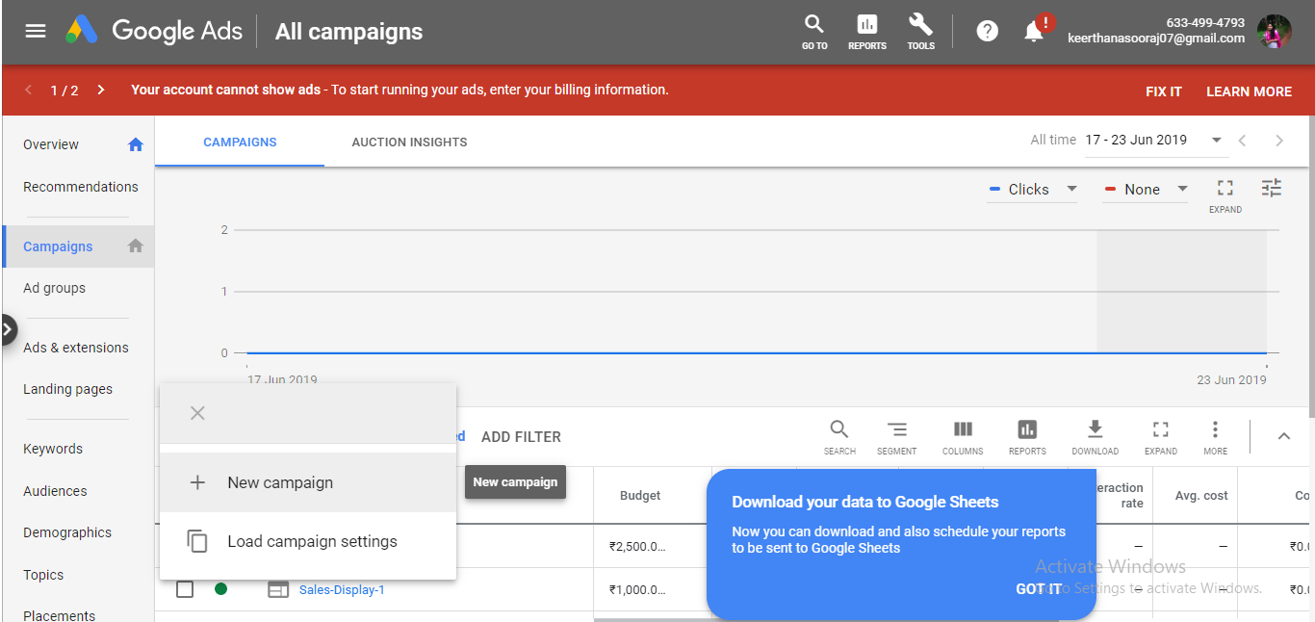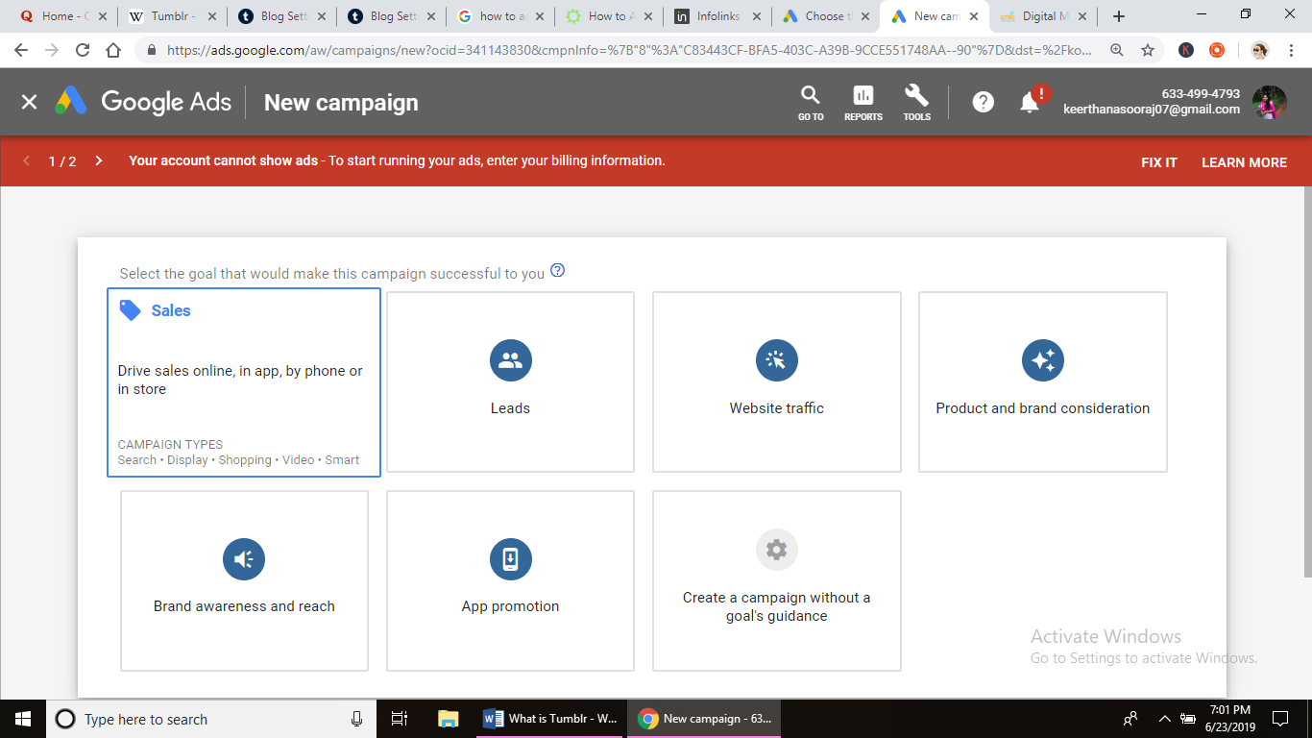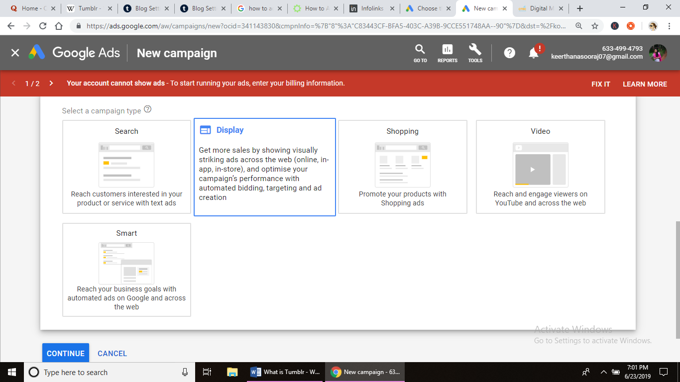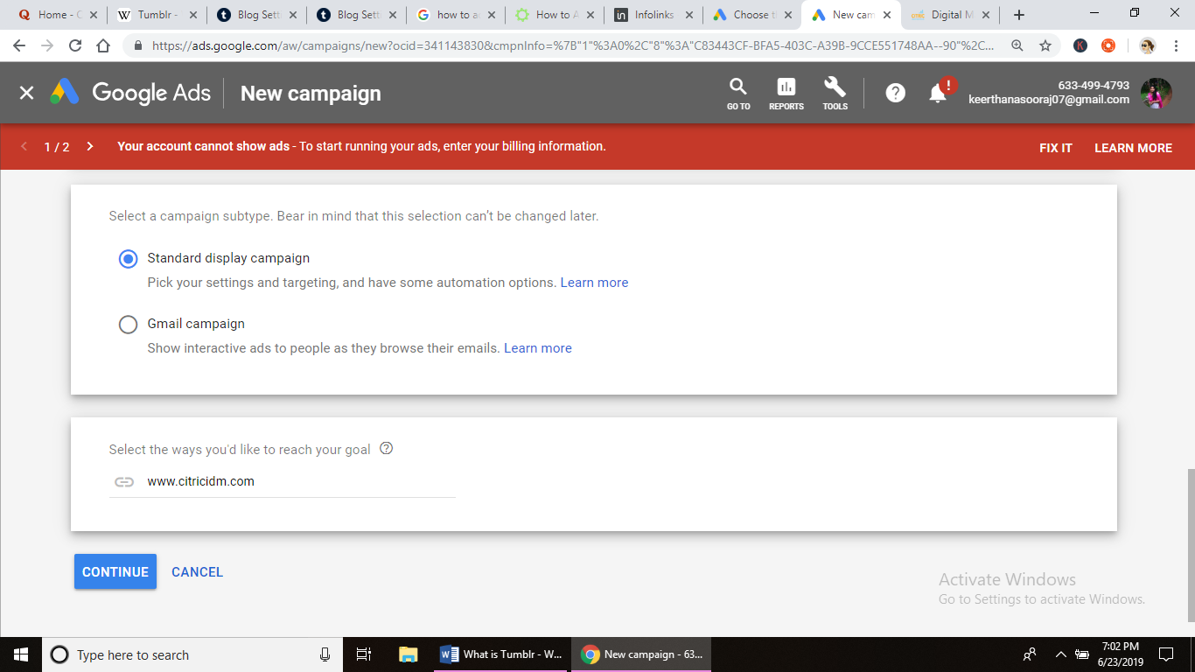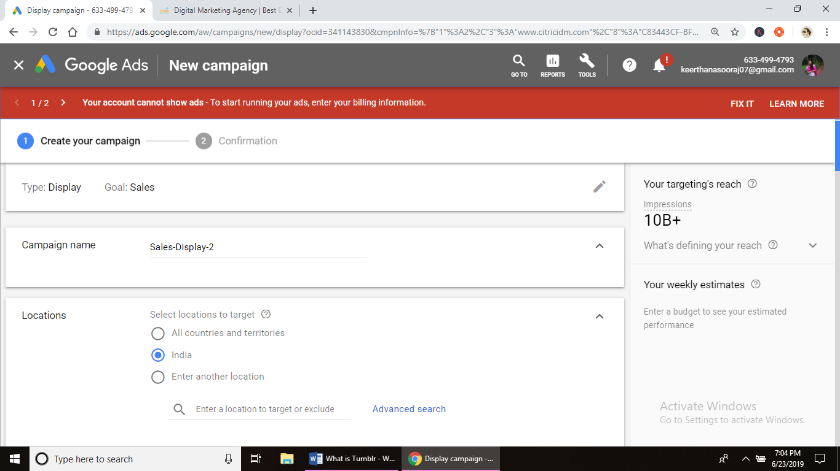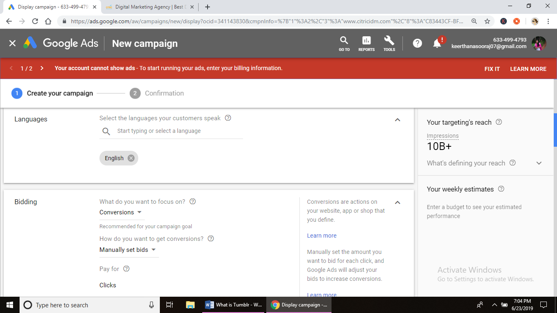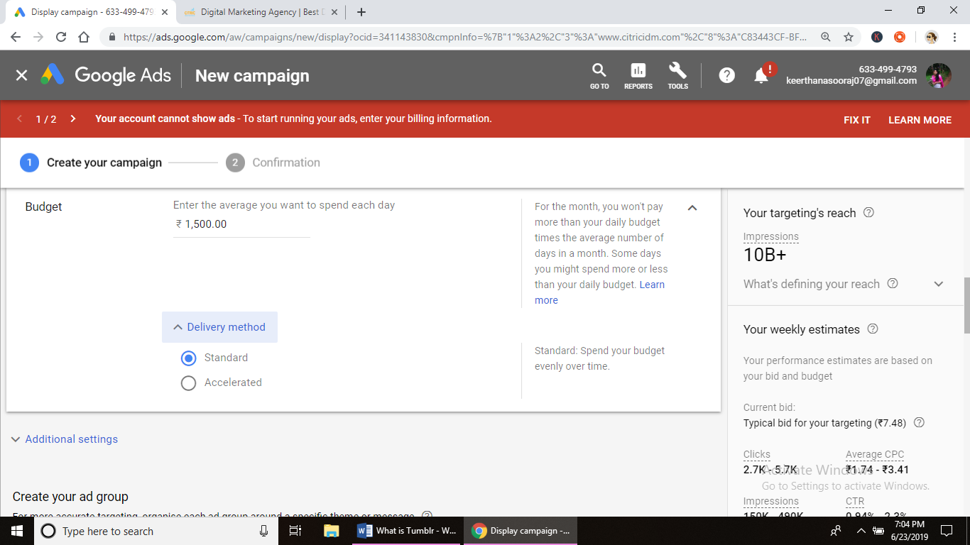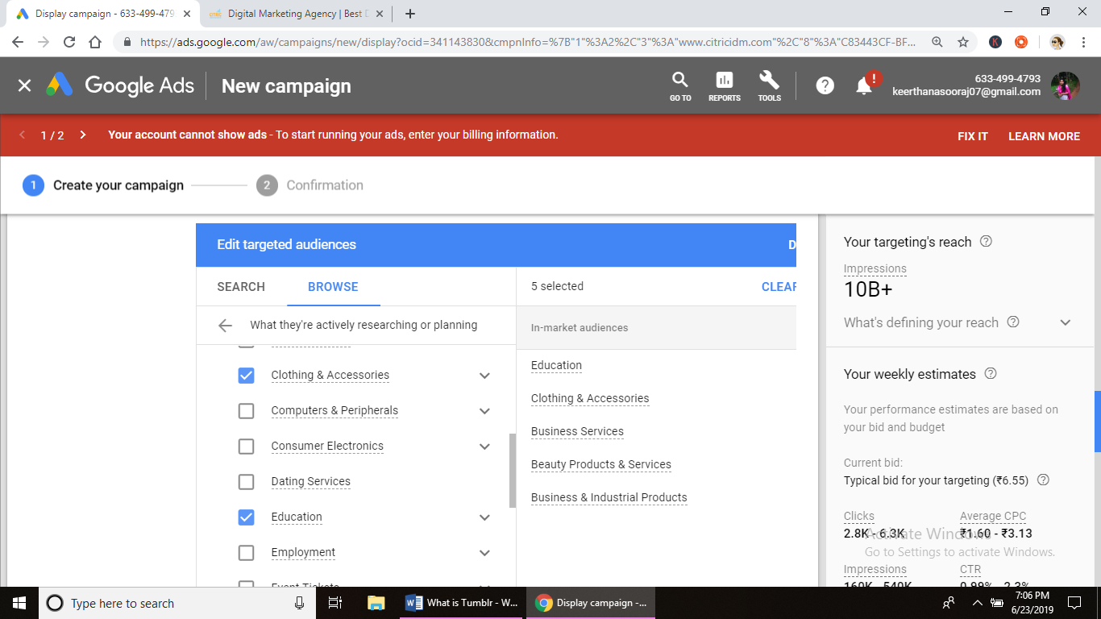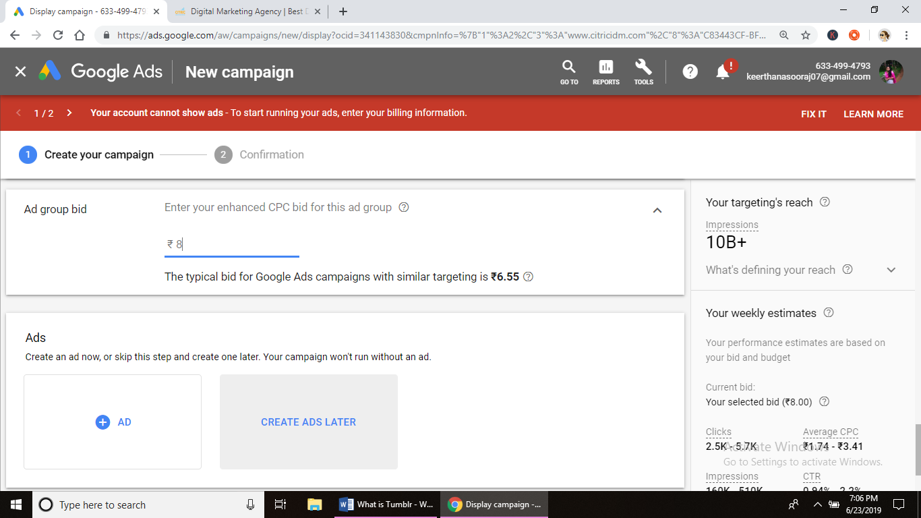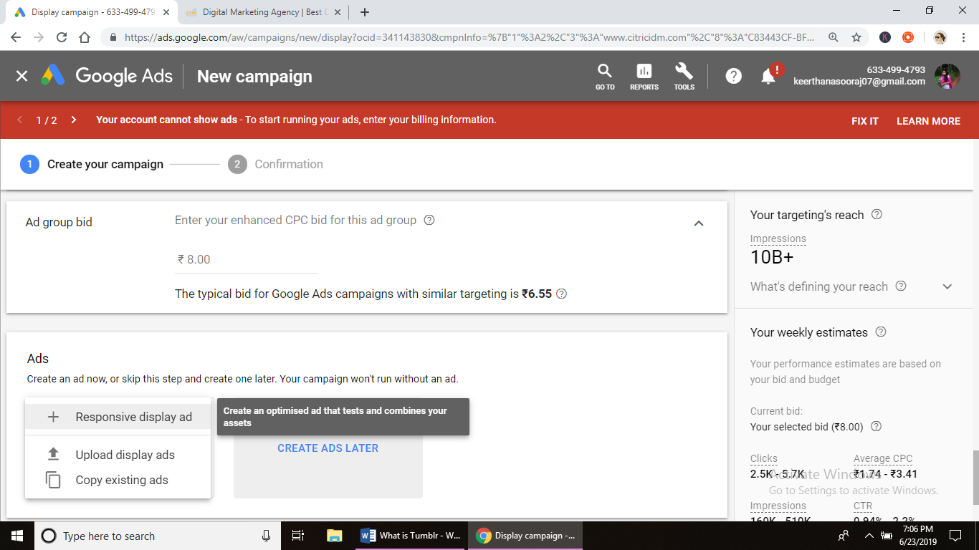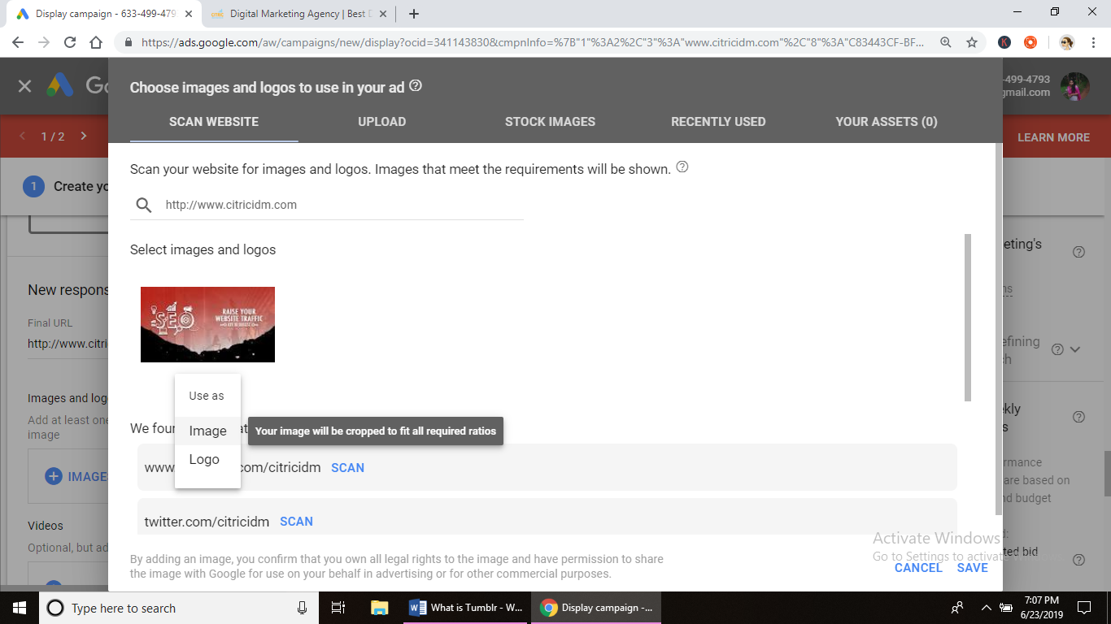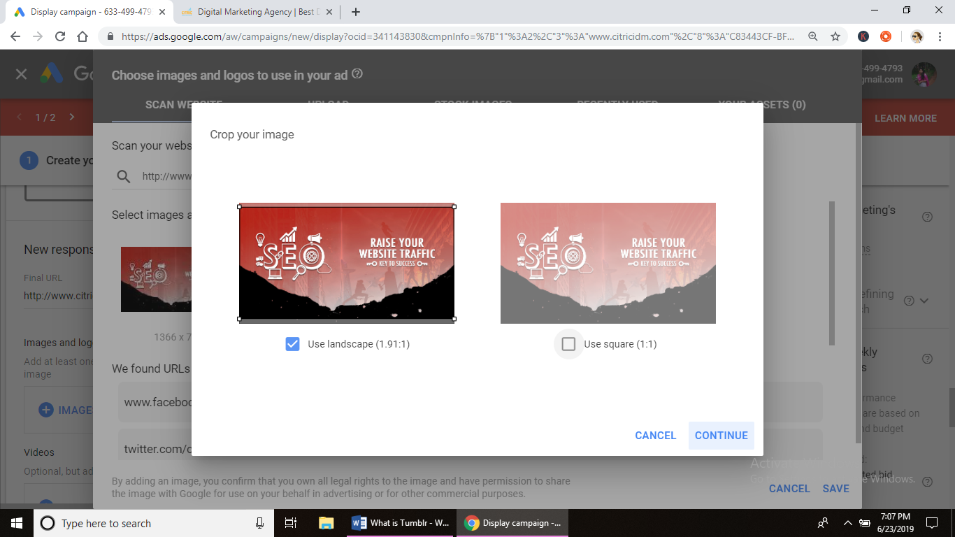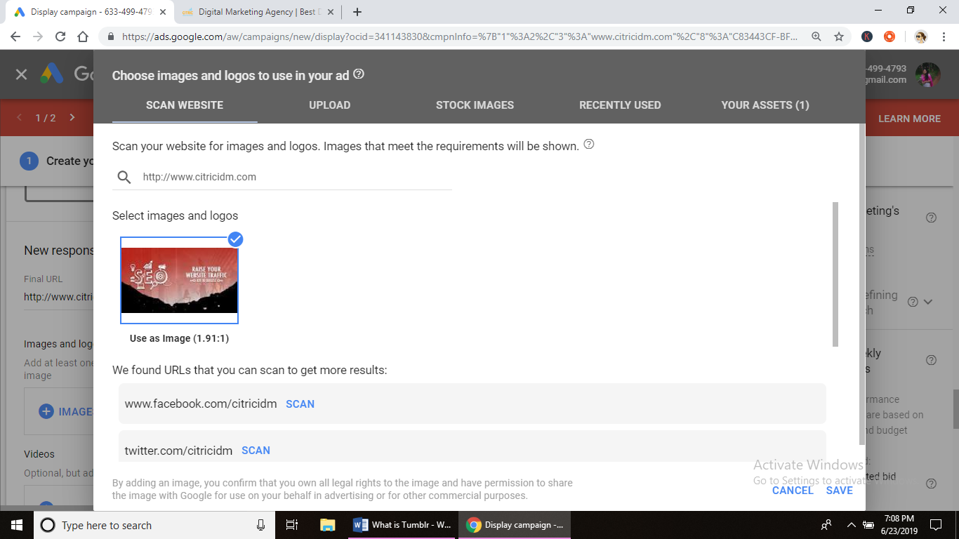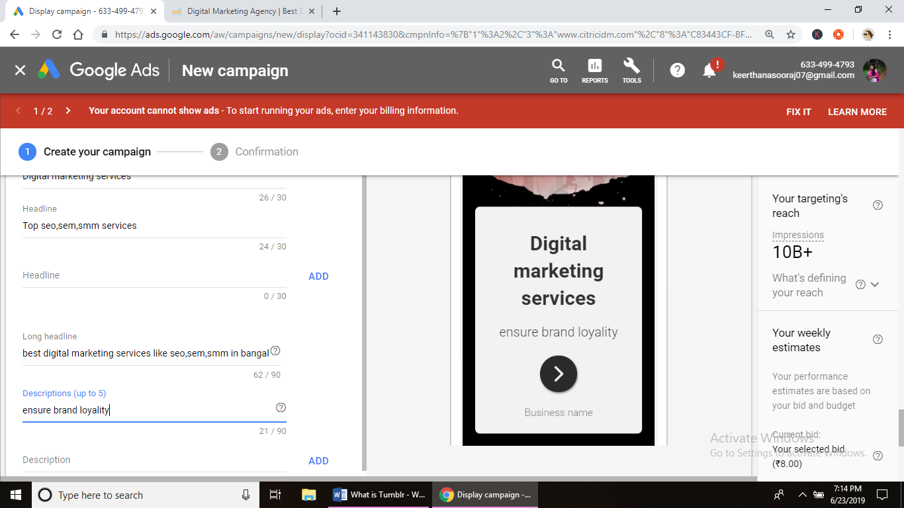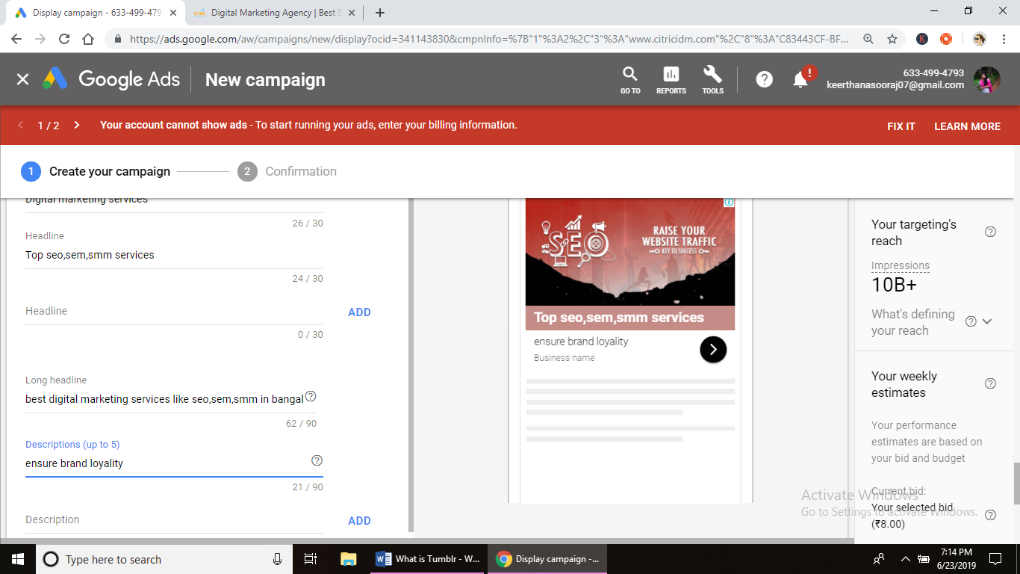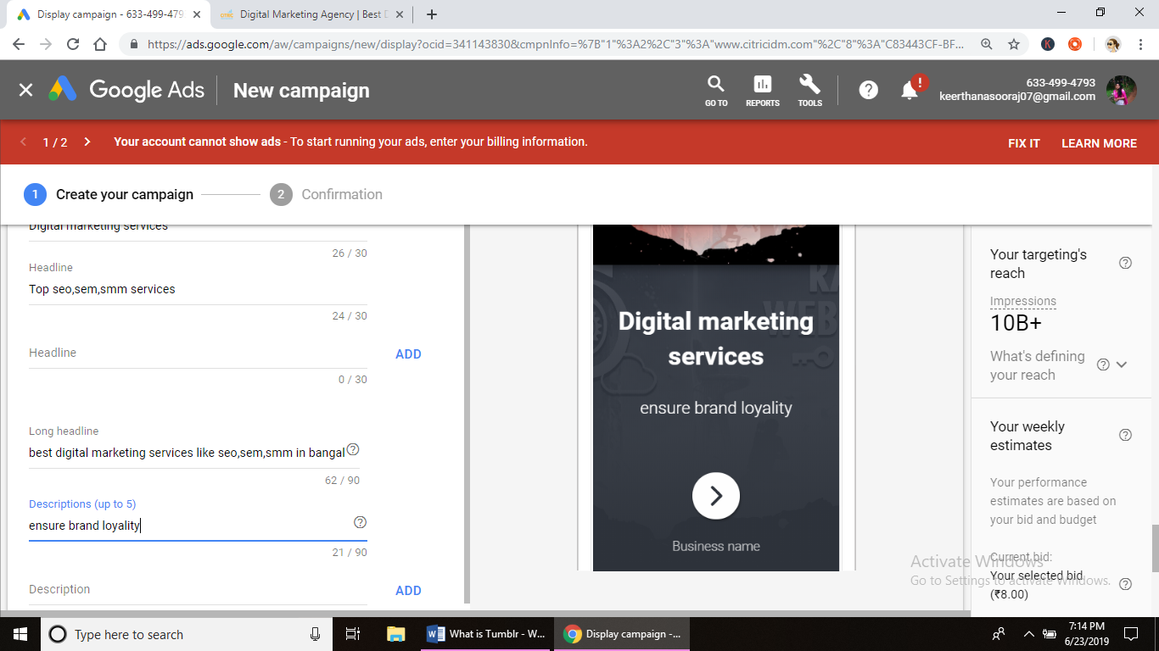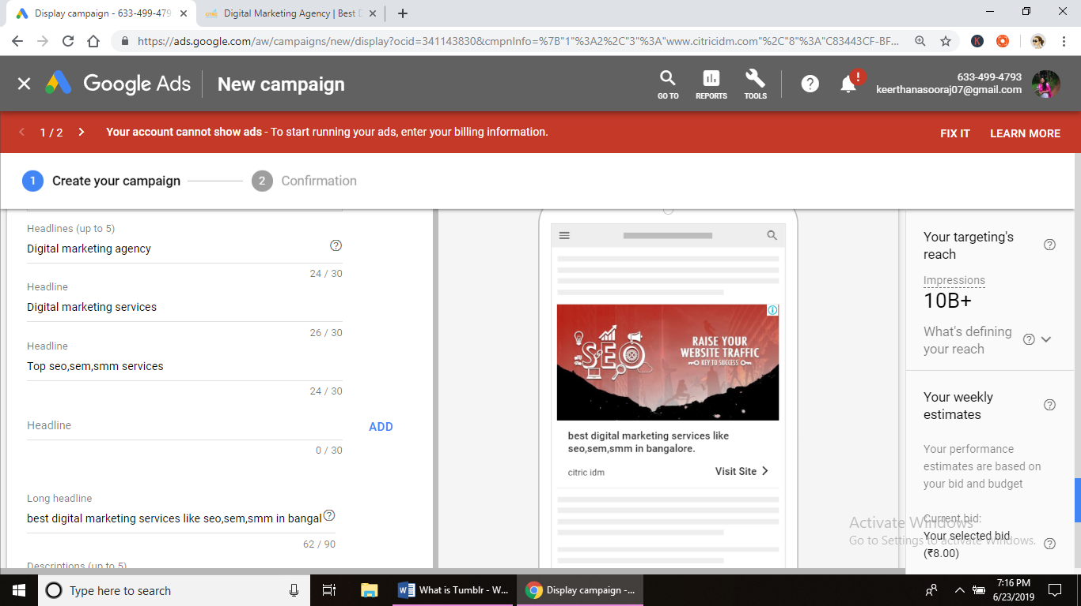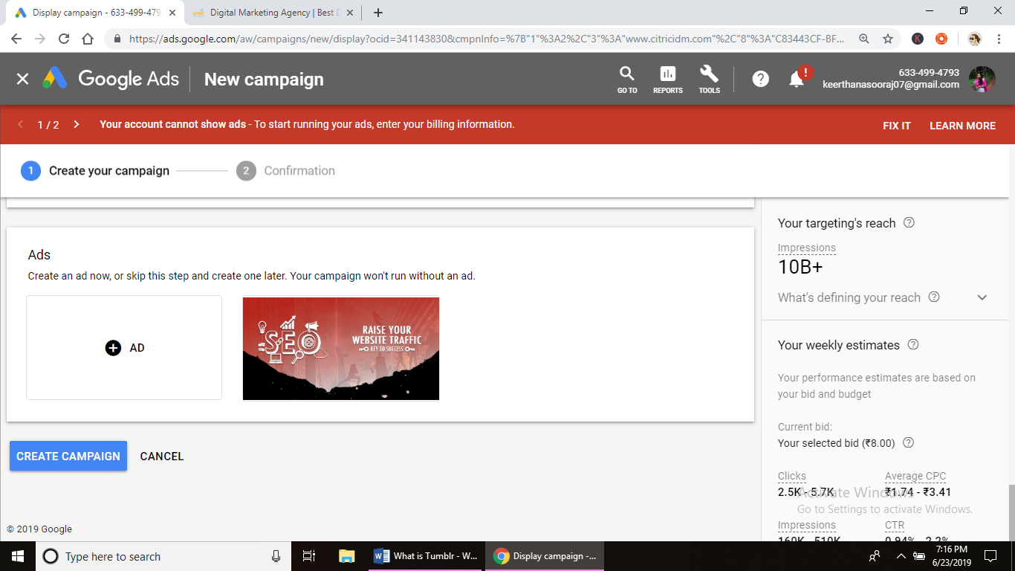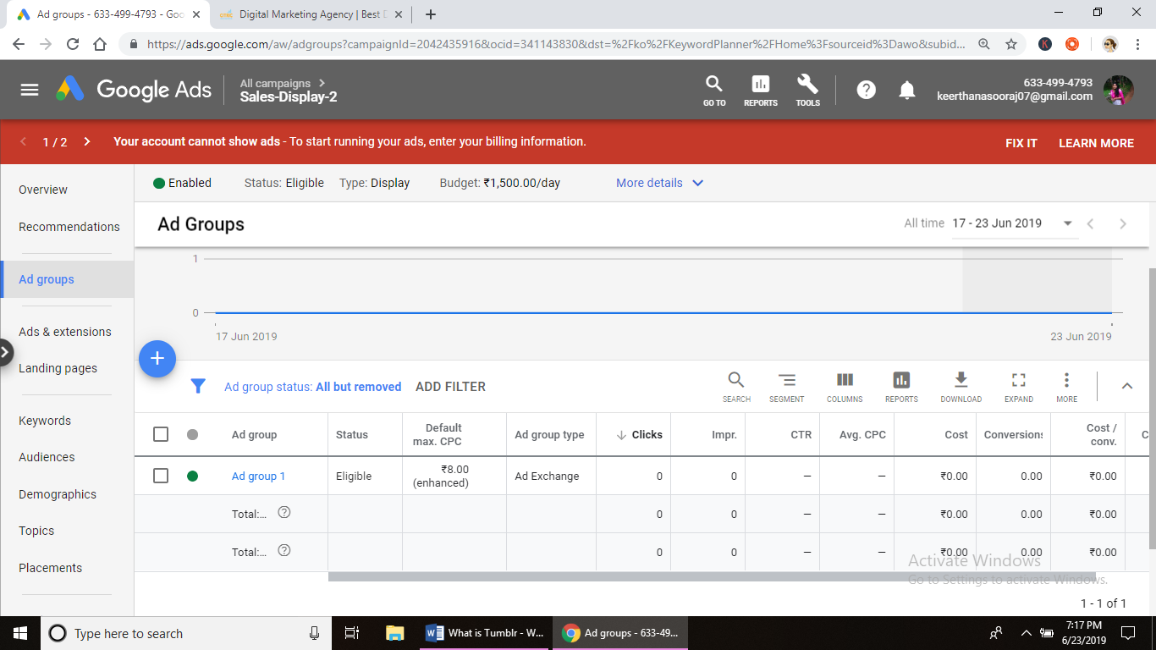

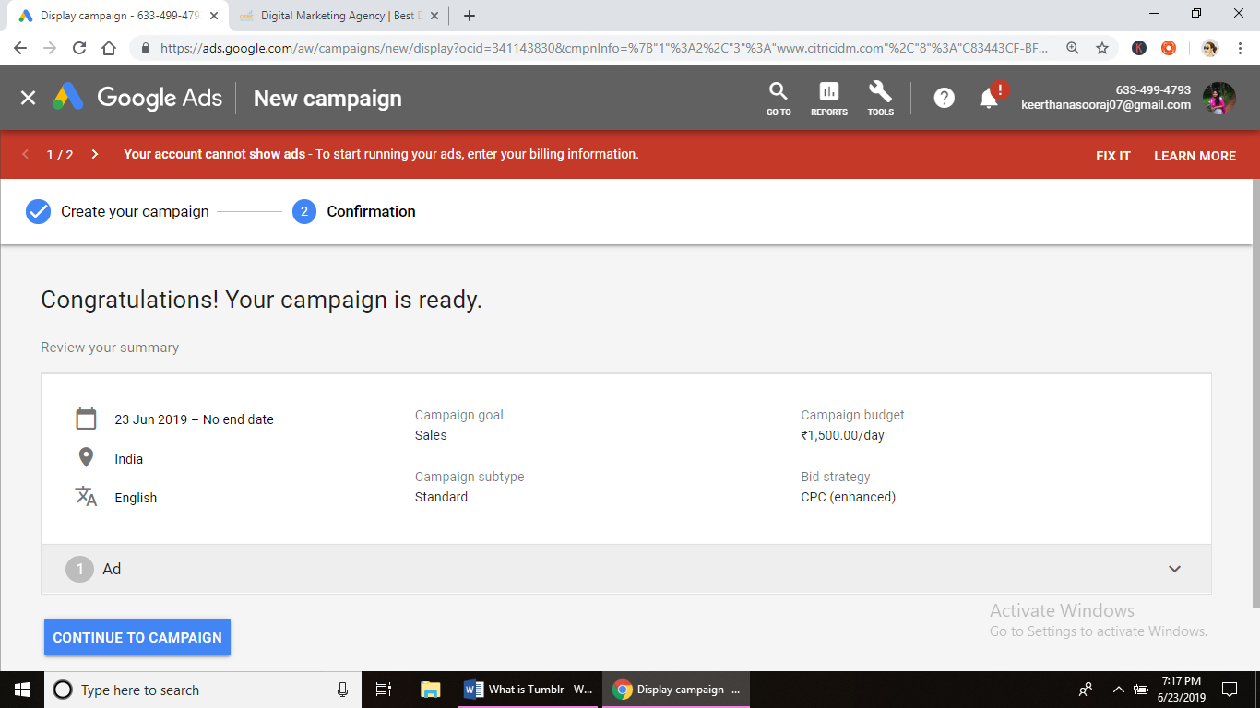

**Assignment – DATE: 11/6/19**

**Assignment Name:**

**Faculty- NIKAHATH**

**Q1. -**

**A1.**

**What is Tumblr?**

Tumblr is a microblogging and social networking website founded by David Karp in 2007 and owned by Media. The service allows users to post multimedia and other content to a short-form [blog](https://en.wikipedia.org/wiki/Blog). Users can follow other users' blogs. Bloggers can also make their blogs private. Many of the website's features are accessed from a "dashboard" interface.

**Features**

**Dashboard:** The dashboard is the primary tool for the typical Tumblr user. It is a live feed of recent posts from blogs that they follow. Through the dashboard, users are able to comment, reblog, and like posts from other blogs that appear on their dashboard. The dashboard allows the user to upload text posts, images, video, quotes, or links to their blog with a click of a button displayed at the top of the dashboard.

**Queue:** Users are able to set up a schedule to delay posts that they make. They can spread their posts over several hours or even days

**Tags:** Users can help their audience find posts about certain topics by adding tags.

**HTML editing:** Tumblr allows users to edit their blog's theme HTML coding to control the appearance of their blog.

**Mobile Apps:** Other than website app for Android, IOS, and Windows Phone is also available.

**Inbox and messaging** : On November 10, 2015, Tumblr introduced an integrated instant messaging function, allowing users to chat between other Tumblr users. The ability to send posts to others via the Dashboard was added the following month.

**How to add ads to tumblr post.**

1. Create an Account on an Advertising Platform

Visit the home page of [Google AdSense](https://www.google.com/adsense), [Bing Ads](https://bingads.microsoft.com/) or [Infolinks](http://www.infolinks.com/) -- three of the largest online advertising platforms -- and complete the account creation process. Wait for the platform to approve your account.

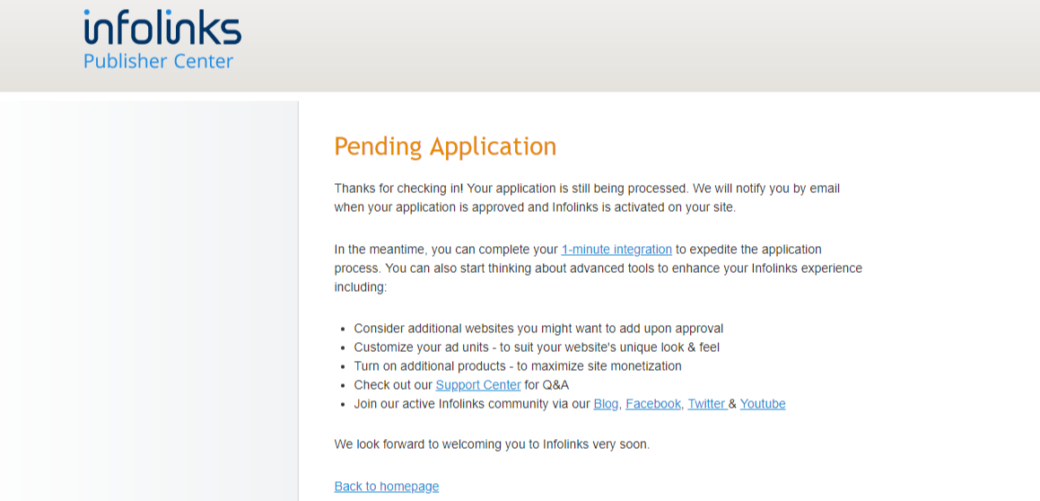

1. Copy the HTML code supplied by the platform into your Windows clipboard.

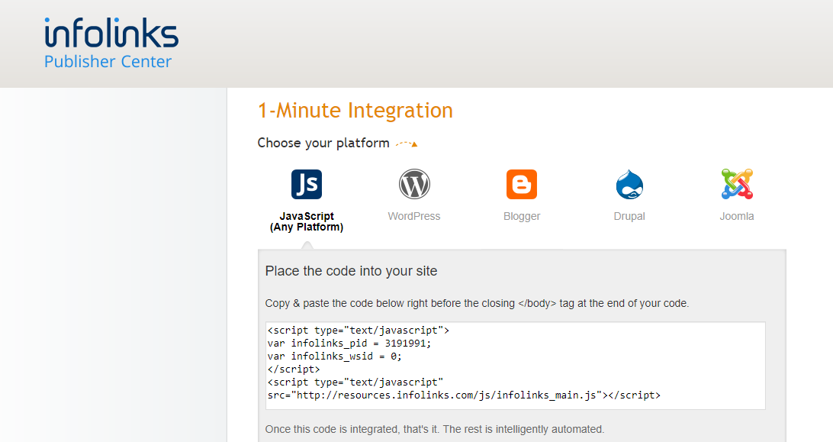

1. Paste the Code Snippet in Your Blog's HTML Code.
2. Select **Edit Appearance** from the **Account** menu on your [Tumblr dashboard](https://www.tumblr.com/dashboard).

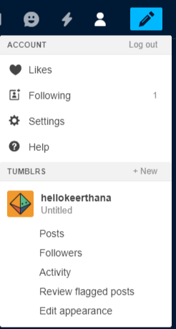

1. Click the **Edit Theme** button.

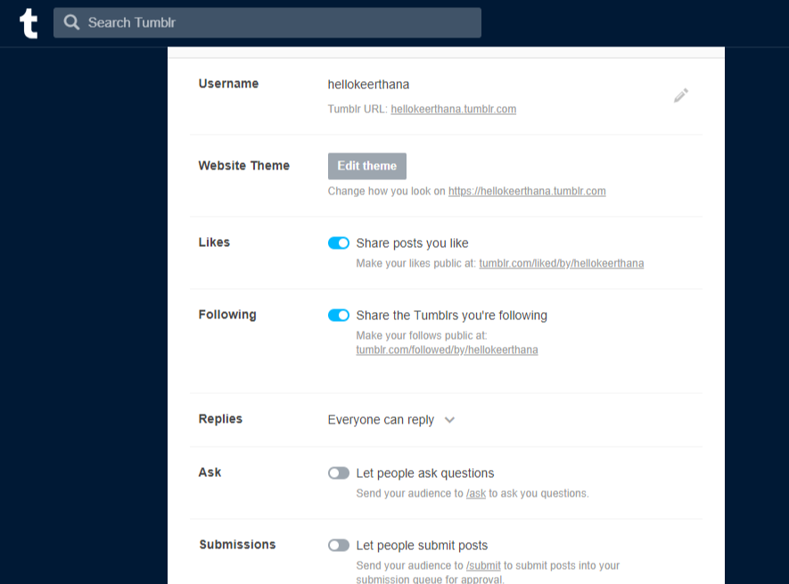

Click the **Edit HTML** link to reveal your blog's source code.

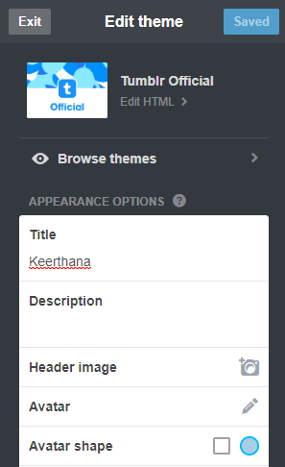

1. Paste the HTML code snippet supplied by the ad platform into your blog's source code at the place where you want the ad to appear. Click the **Update Preview** button and use the preview pane to check whether your ad displays correctly.

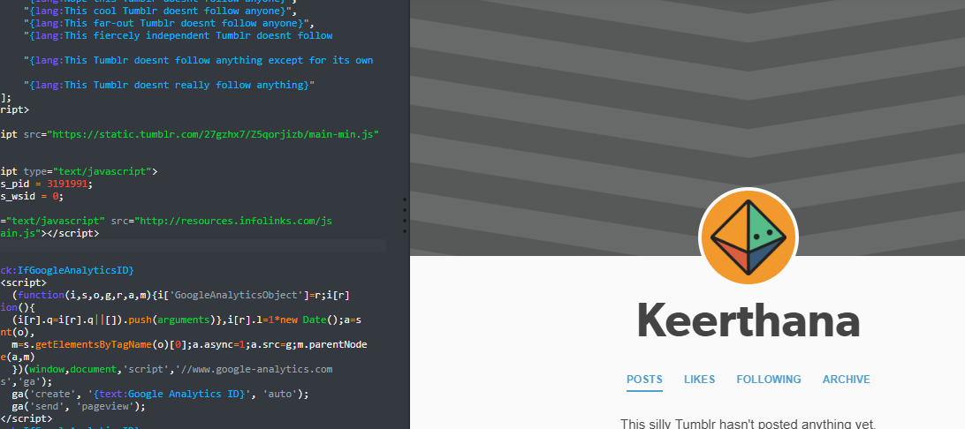

1. Click the **Save** button to save and publish your changes.